Reading Policy
Key Stage 1

Reading Intent

Reading, writing, speaking and listening lay the foundation for lifelong learning and work; they allow children to access all curricular areas and by being literate, all learners will therefore be able to embrace a wider range of opportunities in all aspects of their lives. At All Saints we believe that reading is fundamental to all areas of education so a holistic approach is taken in order for every child to become the best reader possible.

Within Key Stage 1, we aim for our pupils to:

- Be able to read and speak at, at least an age appropriate level.
- Be secure in sounding and blending unfamiliar words quickly and accurately, by using the phonics knowledge and skills that they have learnt so that they are confident, fluent readers who have a good understanding.
- Be exposed to a wide variety of texts, through reading and listening, including different genres and authors.
- Read daily, across the curriculum.
- Develop a love of reading for pleasure.
- Demonstrate motivation to read.
- Be able to discuss a wide range of books with teachers and other adults.
- Develop a widening vocabulary, which supports the ability to develop a secure understanding the ability to discuss what they have heard.

In addition to this:

- All teachers will have high expectation and there is a shared and consistent approach to teaching and learning.
- Each classroom is ‘text-rich’ and provides high-quality books and reading resources which are used across the wider curriculum so that children are able to use their developing reading skills to access further learning.

Reading Implementation

Teaching and learning

We teach reading in line with the aims of The National Curriculum:

- Word reading
- Comprehension (both listening and reading)

Additionally, the National Curriculum sets out statutory requirements for each year group which we use to ensure that children are being developed and challenged at an appropriate level. All staff have a clear understanding of the KS1 content domains and the end points for their year group.

We have based our strategies and approach on research and recommendations from the EEF (Education Endowment Foundation).

Skilled word reading (Fluency)

To ensure that our pupils become readers who are secure in sounding and blending unfamiliar words quickly and accurately, we have a consistent and robust approach to the teaching of phonics. To support us in the delivery of this we use the ‘Little Wandle’ phonics programme (please see our Phonics Policy for further information).

We recognise the importance of ensuring that pupils accurately use the phonics knowledge and skills learnt to enable them to become confident, fluent readers. Fluent reading is exemplified within our quality first teaching and in addition we ensure that every child reads, every day. To ensure that children are getting a varied reading experience, we use a range of strategies: choral reading, paired reading, repeated reading and individual reading. This are visible within each classroom across the school day.

National Curriculum content domains and how they link to the Reading Vipers:
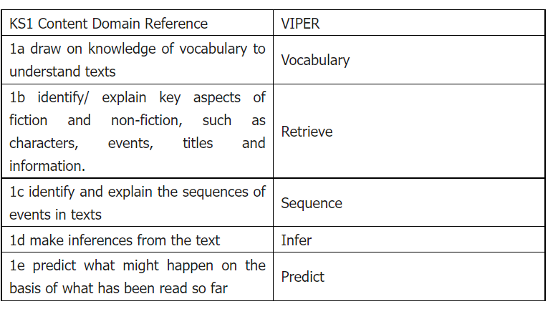

We are following the EEF (KS1 Literacy) recommendation for the specific reading strategies to be taught:

We believe that the highlighted strategies below, are best taught through all aspects of reading learning and interweave skills throughout the teaching of reading, through fluency, comprehension, immersion, discussion and drama.

Questioning—pupils answer questions about a text read and are able to generate their own questions to check their own understanding.
Clarifying—pupils identify areas of uncertainty, which may be individual words or phrases, and seek information to clarify meaning.
Activating prior knowledge— pupils think about what they already know about a topic, from reading or other experiences, and try to make links. This helps pupils to infer and elaborate, ask questions to fill in missing or incomplete information and use existing mental structures to support recall.
Vocabulary-pupils identify the words that they do not know the meaning of, so that their understanding can be deepened, with a clear focus on developing pupils knowledge and understanding of Tier 2 vocabulary.
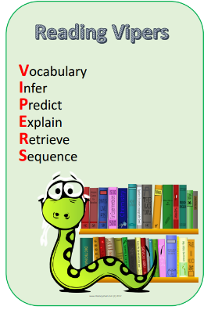
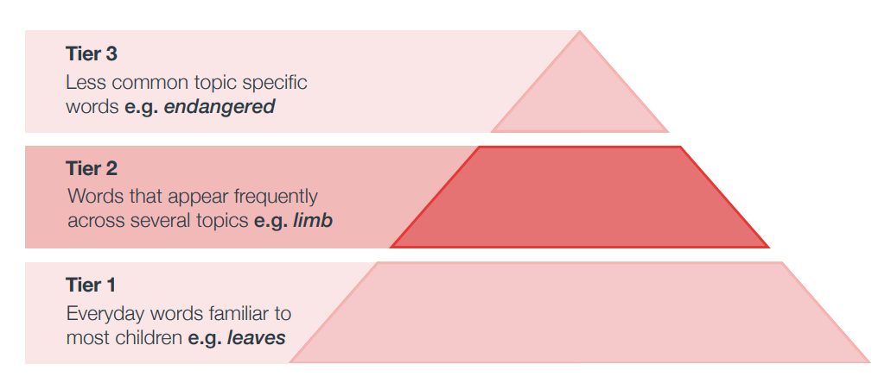
We will interweave the other EEF recommendations through our teaching of the ‘Reading Vipers’

Prediction—pupils predict what might happen as a text is read. This causes them to pay close attention to the text, which means they can closely monitor their own comprehension.
Summarising— pupils succinctly describe the meaning of sections of the text. This causes pupils to focus on the key content, which in turn supports comprehension monitoring. This can be attempted using graphic organisers that illustrate concepts and the relationships between them using diagrams.
Inference—pupils infer the meaning of sentences from their context, and the meaning of words from their knowledge of phonics.
The VIPERS terminology is there as reference for teaching staff.

The children will have the opportunity to access a wide variety of texts over the term, these will include: a book study (2 week block, linked to a writing unit), short extracts, poetry/songs, picture books, video clips and non-fiction texts (often linked to the wider curriculum, as well as equality and diversity).
Please see year group Reading Overviews for further information

Year 2:
Little Wandle is used for teaching phonics and is used with fidelity. 3 x reading sessions are taught per week in Year 2 using Little Wandle.
2 x sessions of reading for fluency are taught per week using various resources and stimuli to encourage reading and discussion.

Year 1:
Little Wandle is used for teaching phonics and is used with fidelity, using Little Wandle books for reading
Reading is taught within English in Year 1 and is captured in English books and using Seesaw.

EYFS: Little Wandle is used for teaching phonics and reading across EYFS alongside access to reading through Continuous Provison.

Story Time

Each class has dedicated story time each day. A high level of repetition and quality discussions ensure that the children know the stories well. Teacher’s actively re-read stories and talk with the children to build familiarity and understanding and allows them to hear new vocabulary over again. Story time includes a range of high quality texts, including modern and traditional tales and experiences and perspectives that are both similar and different to their own. The children are also given opportunities to dramatise stories they know well to deepen understanding.

Poetry

Each year group has their own set of core poems which are shared and taught through the teaching of reading and writing. In addition, within KS1 there is regular, dedicated rhyme, poetry and singing time.

Language Comprehension
We have a robust and deliberate approach to embedding and extending vocabulary across the curriculum and this includes plenty of repetition. All classrooms are ‘language-rich environments’, across all subjects. Staff provide regular opportunities for purposeful interaction and discussions pupil/pupil and pupil/adult are evident within all classes. Pupils are actively taught the routines for back and forth talk.

Reading Stamina

We actively encourage and teach children to build a good reading stamina. We do this through reflective reading practise, the children learn to recognise how long they are able to focus and read independently for and are then challenged to increase this for longer periods of time without being distracted or without distracting others.

Recording reading

In Key Stage 1 all children have a personal reading record. These record the books that the children have read at home and are completed by parents. In addition, staff keep records of the children’s progress in reading. These focus on both their word reading and their comprehension skills.

Assessments

We assess the children’s fluency and comprehension skills in a variety of ways, to ensure we have a clear understanding of each individual as a reader and any potential barriers to support them to make progress.
Word reading/ Fluency | Comprehension
Phonics Assessments  Fluency Rubric- to identify specific barriers  Assessing how many words can be read per minute (3 x year) | On-going assessments through a variety of ways including: AfL opportunities, high quality questioning and feedback.  Practice DfE SATs papers (Y2)

Barriers to reading
When assessing reading barriers staff are rigorous in ensuring that we are specific in our diagnosis.
Fluency: expression and volume, phrasing, smoothness and pace.
Reading Comprehension: vocabulary, grammatical development, verbal reasoning, inferencing, verbal working memory and motivation to read.

Enhanced provision through QFT and where appropriate, specific, targeted interventions are put in place to support children to overcome their reading barriers.

Provision for bottom 20% Readers

- Rigorous assessment to identify specific barriers.
- Enhanced provision through QFT- including additional opportunities for reading for pleasure.
- High focus within reading lessons and when the class text is shared.
- Further opportunities for them to discuss what they have read and what they enjoy reading.
- A reading book that is matched closely to their reading ability/ phase in phonics.
- Focused interventions (fluency and comprehension as appropriate).

Whole Key Stage Strategies to embed a strong reading culture.

- Class book read daily, with a high focus on ensuring that children understand tier 2 vocabulary.
- Each classroom has a high quality book area, where ‘every book is worth reading aloud’.
- Classrooms will be text rich and have books that link to the wider curriculum.
- Buddy reading system where UKS2 children will read with key stage 1 children.
- Celebrate Word Book Day each year.
- Scholastic book fair to visit twice a year.
- Opportunities for a range of authors to visit school.

Reading Impact

- Pupils enjoy reading regularly for information, enjoyment and pleasure.
- Pupils discuss books with excitement and interest.
- Progression in skills is evident across the year, and year groups- this is evident in pupil outcomes.
- Purposeful feedback moves the learning forward and the children respond to the feedback and are able to explain what they need to do next to improve.
- Presentation is of a high standards and in line with the school policy.
- Teachers track pupil progress and this informs planning and intervention.
- Subject leader monitoring is purposeful and evidences good practice (this includes: learning walks, learning quality assurances, lesson observations, pupil interviews, listening to pupils read)
- Pupils identified as having SEND, evidence good progress from their starting points.
- Early identification of need and highly structured Interventions ensure that any child in danger of not meeting the expected standard, has appropriate provision in place.

