 | YEAR 5 PROPERTIES AND CHANGES OF MATERIALS KNOWLEDGE ORGANISER
KEY VOCABULARY AND SPELLINGS  Soluble – able to be dissolved, especially in water  Insoluble – cannot be dissolved, especially in water  Dissolve – when something solid mixes  with a liquid and becomes part of the liquid  Solution – is made when one substance dissolves into another  Reversible change – can be reversed back to its original state  Irreversible chang e – cannot be reversed back to its original state  Transparent – allows light to pass through  Thermal conductor - a material or device which allows heat to carry through  Electrical conductor – a material or device with allows electricity to carry through  Magnetic – capable of being magnetised or attracted by a magnet |  | COMPARING AND GROUPING - Materials can be compared and grouped together on the basis of their properties including:  - Hardness – how hard or soft a material is  - Solubility – whether a material can dissolve  - Transparency – whether it allows light to pass through  - Conductivity (electrical or thermal) – whether it allows heat or electricity to carry through  - Response to magnets – whether it is magnetic | PARTICLE ARRANGEMENT  Solid – particles packed closely together 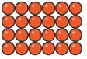  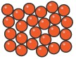  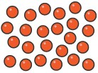  Liquid – particles have some space to move  Gas – particles are free to move
REVERSIBLE AND IRREVERSIBLE CHANGES
REVERSIBLE | IRREVERSIBLE
Dissolving sugar in water | Toasting bread
Freezing water | Cooking a cake
Melting chocolate | A candle melting

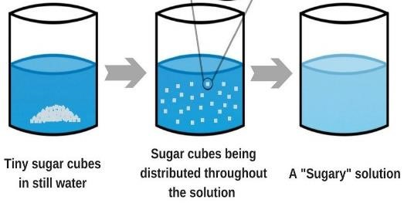
DISSOLVING - Sometimes when a solid (solute) is mixed with a liquid (solvent) it will dissolve to form a solution e.g. dissolving sugar in hot tea.

The solid seems to disappear in the solution but it is still there it has just become part of the liquid.

A soluble material can dissolve however an insoluble material cannot dissolve.
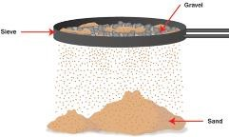
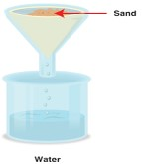
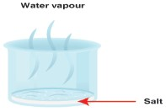
SEPARATING MIXTURES
SIEVING – a mixture of different sized solid particles can be separated with a sieve.

FILTERING – an insoluble solid can be separated from a liquid when passed through a filter. The liquid passes through the solid particles are trapped on the filter.

EVAPORATING – if a solution is boiled (heated) the water will evaporate into gas and the solid will be left behind.

