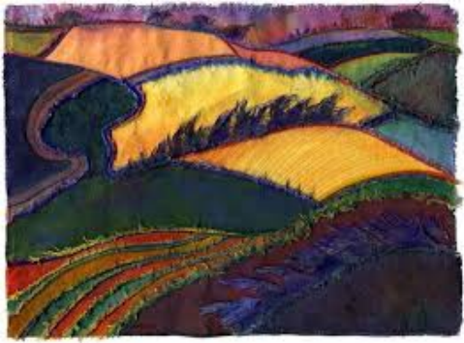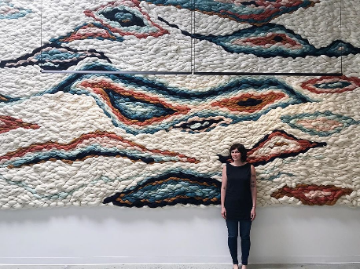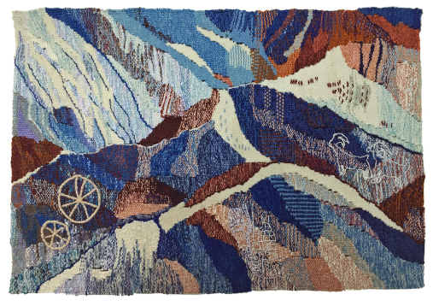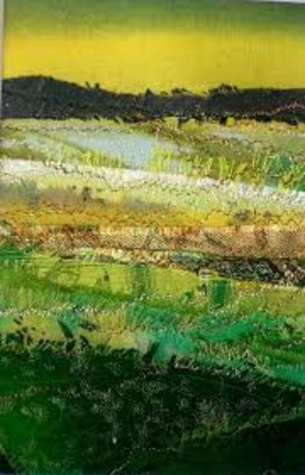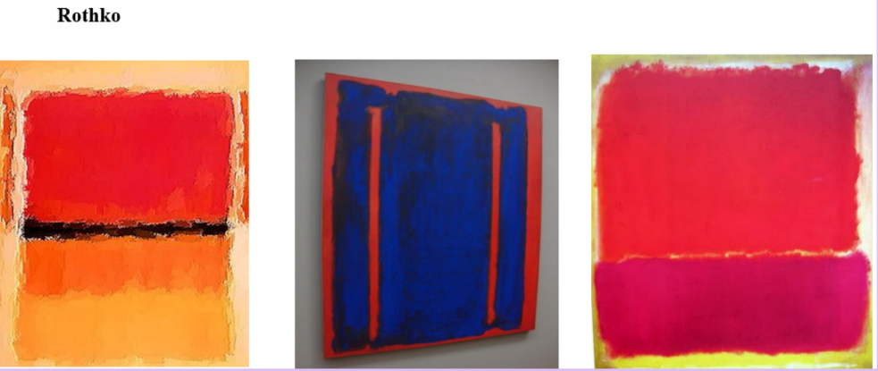

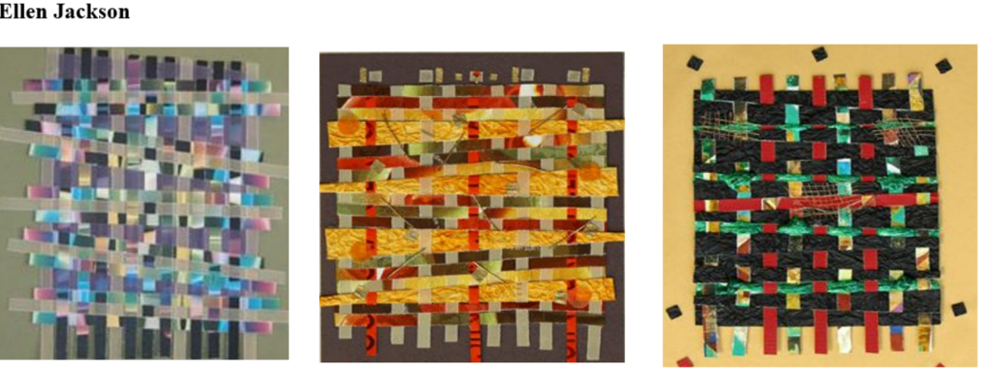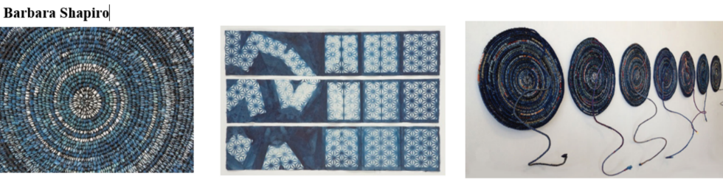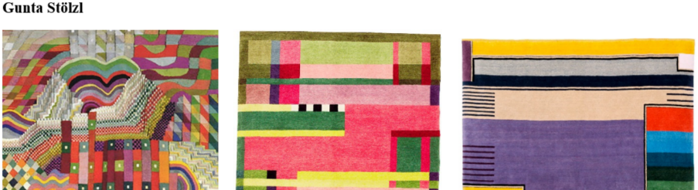

**Mood board**

**Patterns**

**Art Knowledge Organiser**

**Textiles - weaving**

**Colours**

**Vocabulary**Weave

Shape

Pattern

Natural

Man-made

Thread

Texture

Colour

Warp

Weft

Looms.