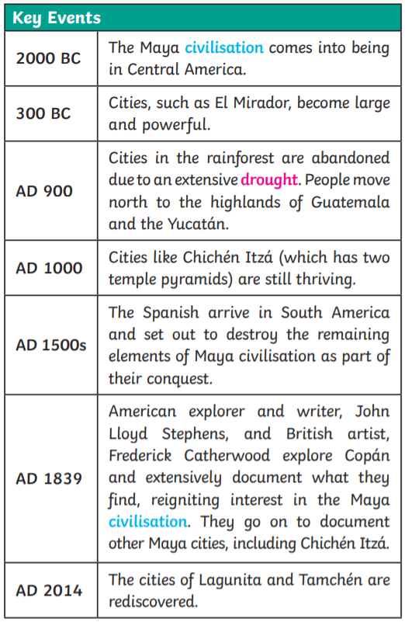
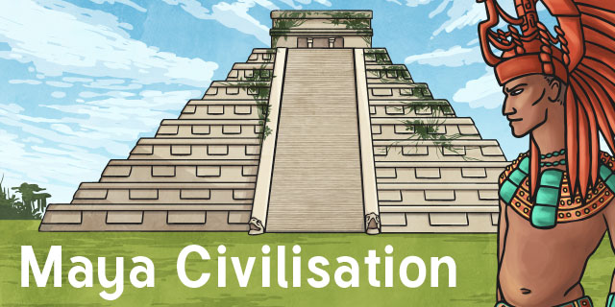
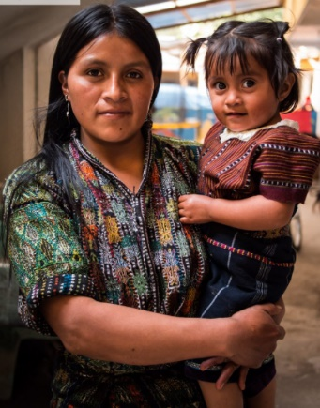

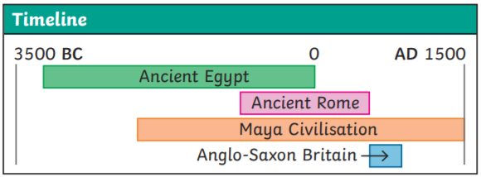
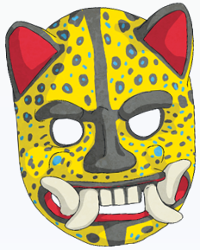
Ancient Maya used masks for a wide variety of reasons. The main material was wood, but other materials include: gold, jade, shell and obsidian!
Event masks were bright an vibrant and were designed on heavenly animals.
Death masks were the most sacred and protected the person into the afterlife.

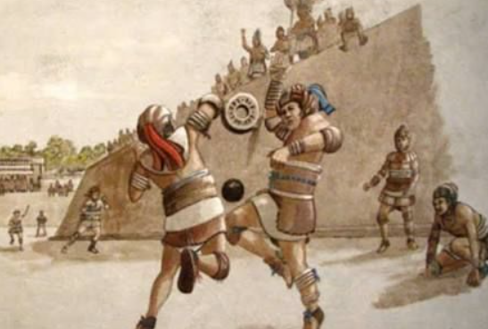
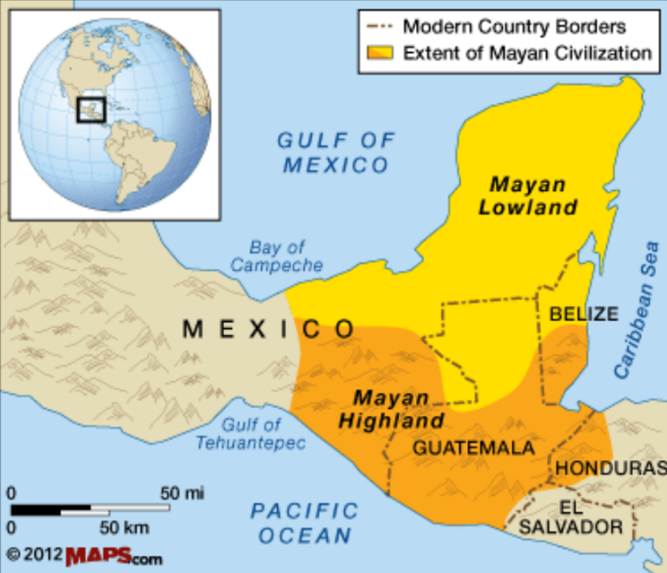
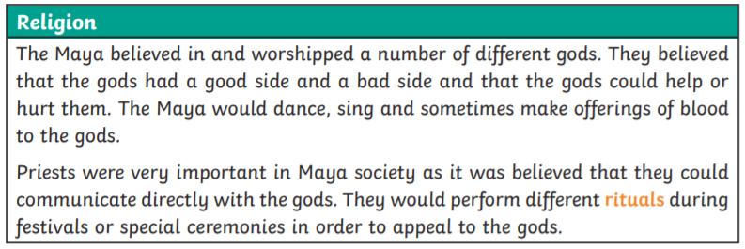
Maya’s most famous game is ‘Pok-a-Tok’. The game was sometimes used to settle disputes instead of going to war. This exciting ball game ends with a HUMAN SACRIFICE!

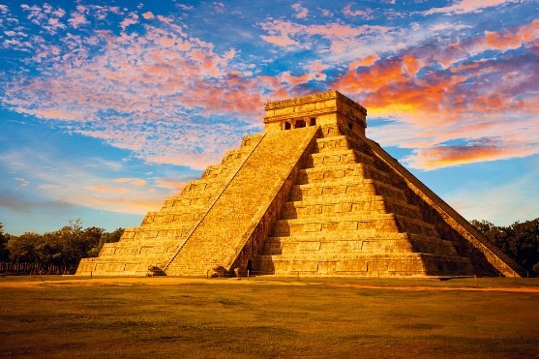

Inventions
The number 0! Maya was one of very few civilisations to discover the idea of 0 in counting. | Hot Chocolate!  Using cacao beans, Ancient Maya made a hot drink. It was bitter though.
A Calendar!  Ancient Maya invented a calendar up to 2012! | 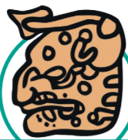  Writing!  Maya used hieroglyphs to communicate ideas.

Chichen Itza – one of Ancient Maya’s most famous temples. Also, a place Mr. Cullen has visited!

If the Maya were so advanced, what happened to them? There are many theories including: politics, war, famine and invasion by the Spanish.
Key Words
Civilisation | An organised society with its own culture, existing in a particular area.
Maize | Sweetcorn. A crucial crop to Ancient Maya. Often planted with beans.
Codices | Handwritten texts. Maya codices could be unfolded like a concertina.

