Year 1 Materials Knowledge Organiser

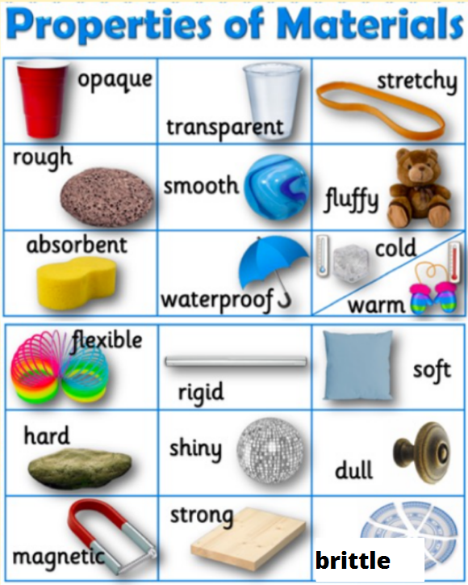
Materials:
Plastic  __________ | Wood  __________ | Metal  __________
Glass  __________ | Paper  __________ | Brick  __________
Fabric  __________ | Stone  __________

