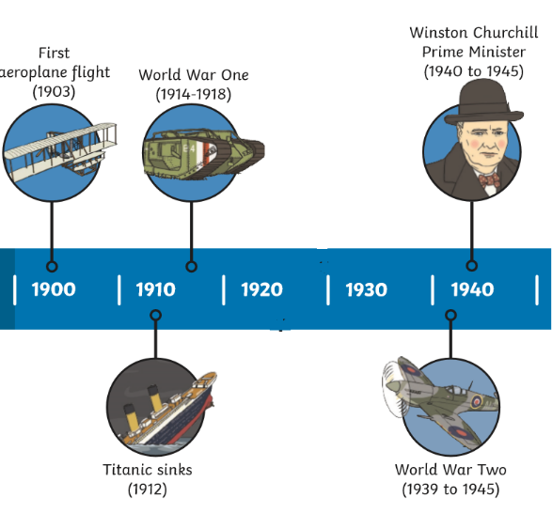

**Hi-Story**

Our village of Waddington is close to Lincoln and next to a large RAF base. Over the last 100 years many changes have happened in the village. Its schools St Michael’s and St Clements joined together to create our school: **Waddington All Saints**. During WW2 the church was bombed and the people of Waddington worked together to get it rebuilt. Over the years the RAF base has also grown in size which means our village has had to grow too. Through our history learning we are going to learn more about how our village was different in the past and why some of the changes have happened.

**Vocabulary**

Past present future

now then

change different

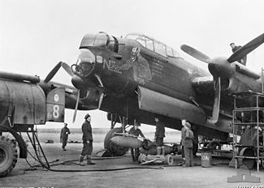

**RAF Waddington**

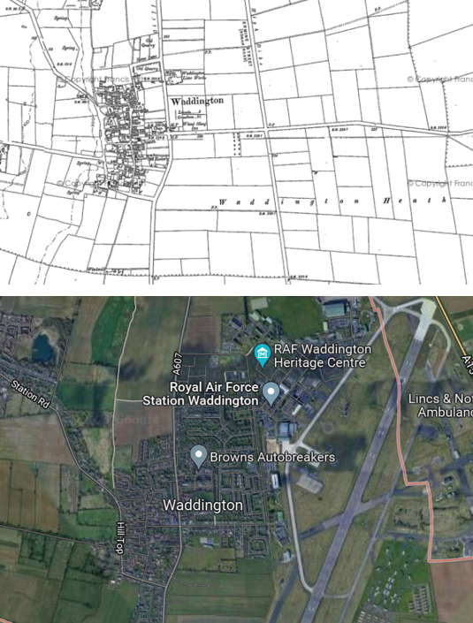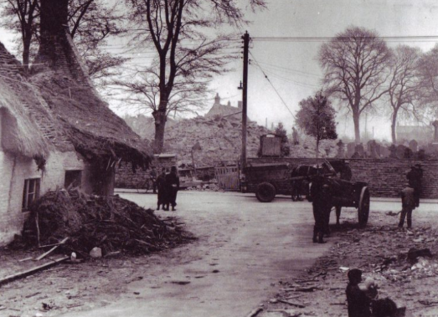 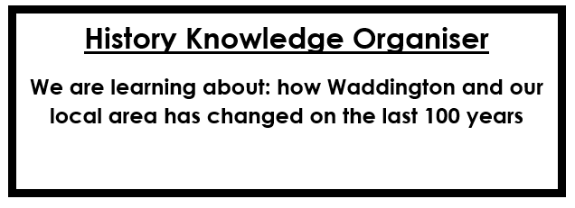

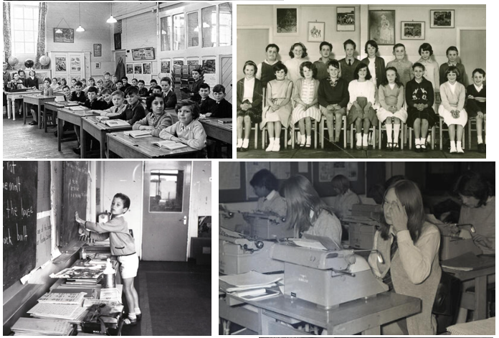

**The church was bombed and rebuilt.**

**Schools in 1960s**

**Maps of Waddington**

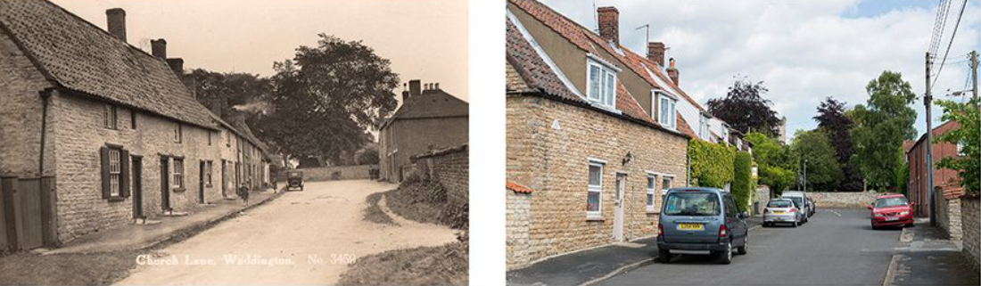

**In the past Now**

**What has changed?**